Snapshot of Project:-

HomePage:-

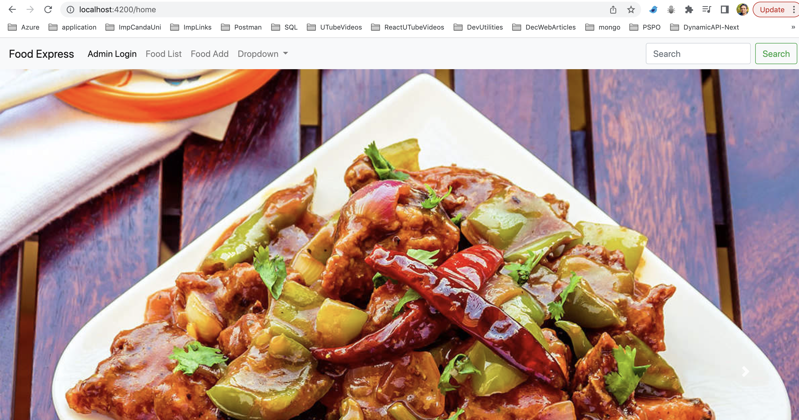

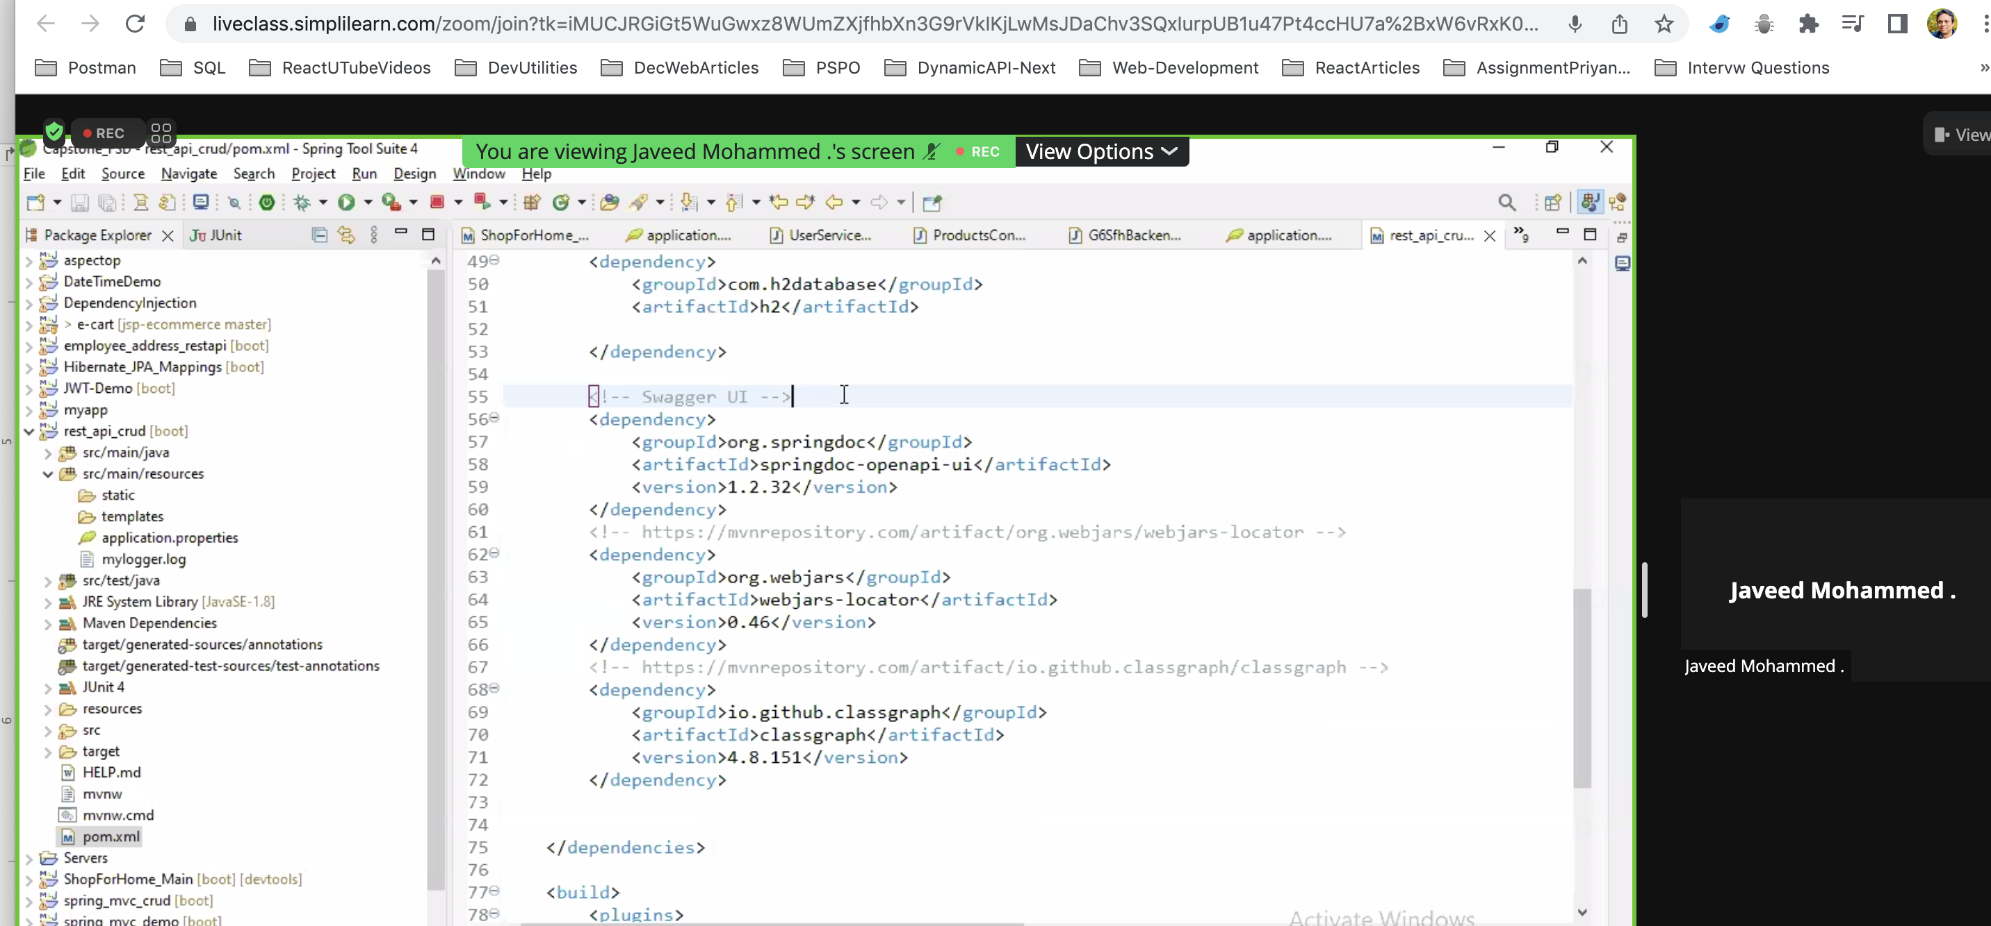

<!-- Swagger UI --> <dependency> <groupId>org.springdoc</groupId> <artifactId>springdoc-openapi-ui</artifactId> <version>1.2.32</version> </dependency> <!-- https://mvnrepository.com/artifact/org.webjars/webjars-locator --> <dependency> <groupId>org.webjars</groupId> <artifactId>webjars-locator</artifactId> <version>0.46</version> </dependency> <!-- https://mvnrepository.com/artifact/io.github.classgraph/classgraph --> <dependency> <groupId>io.github.classgraph</groupId> <artifactId>classgraph</artifactId>

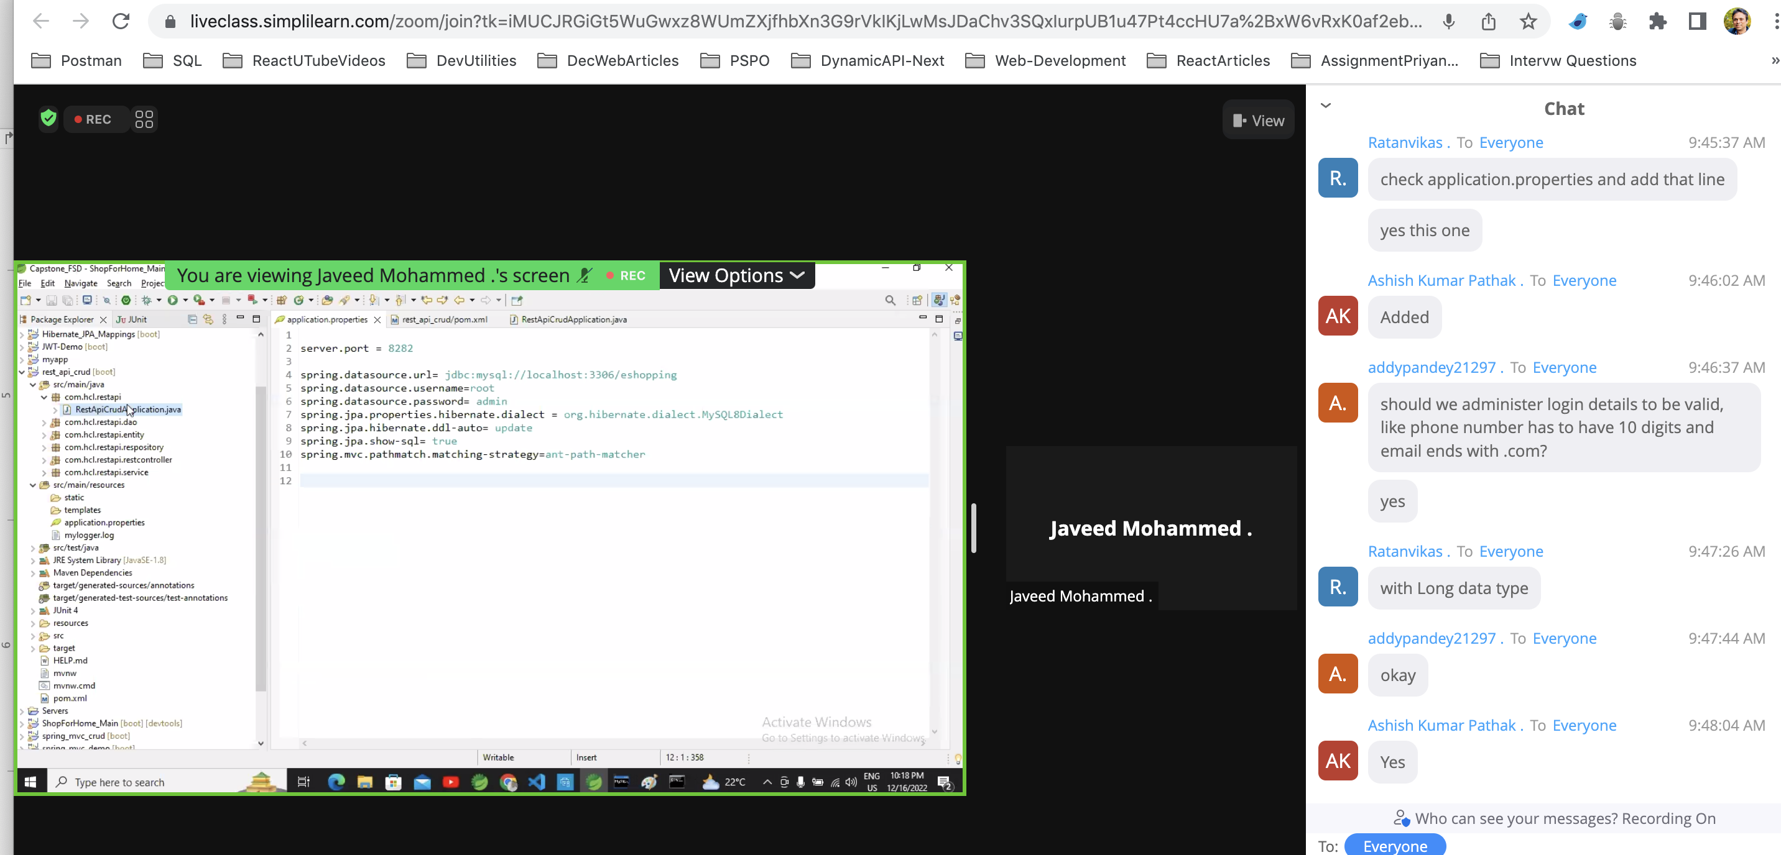<version>4.8.151</version> </dependency>

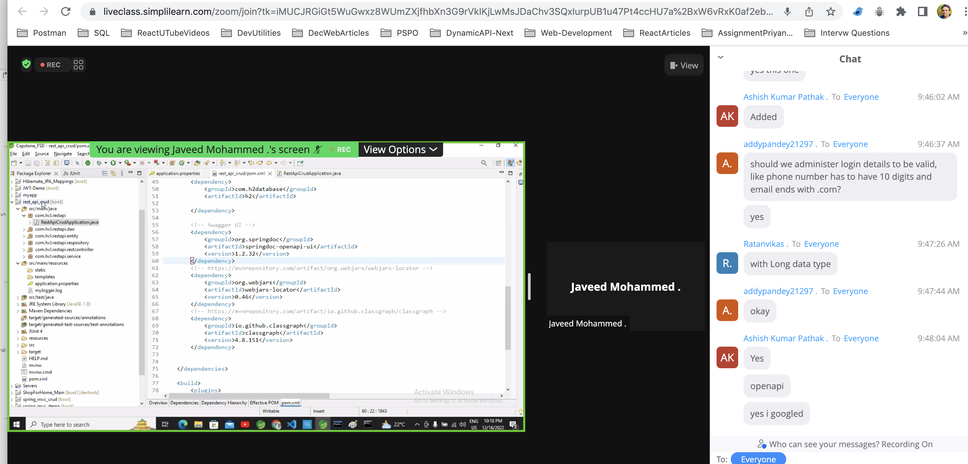

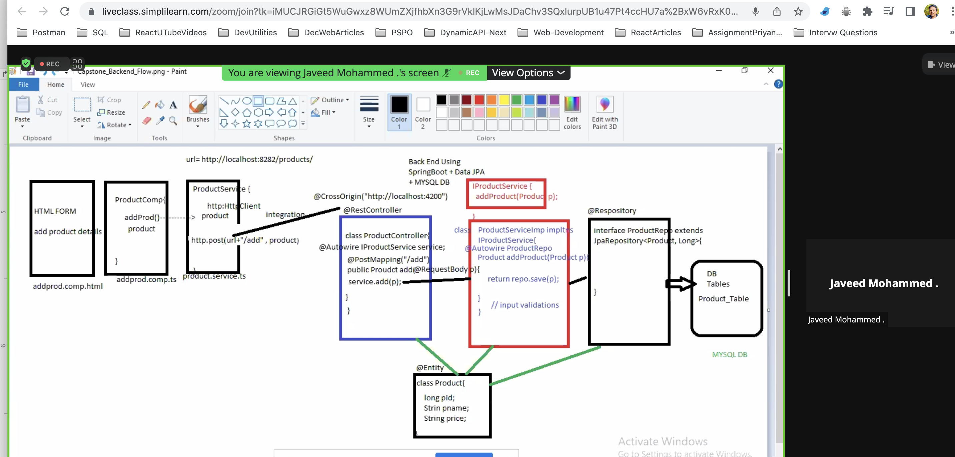

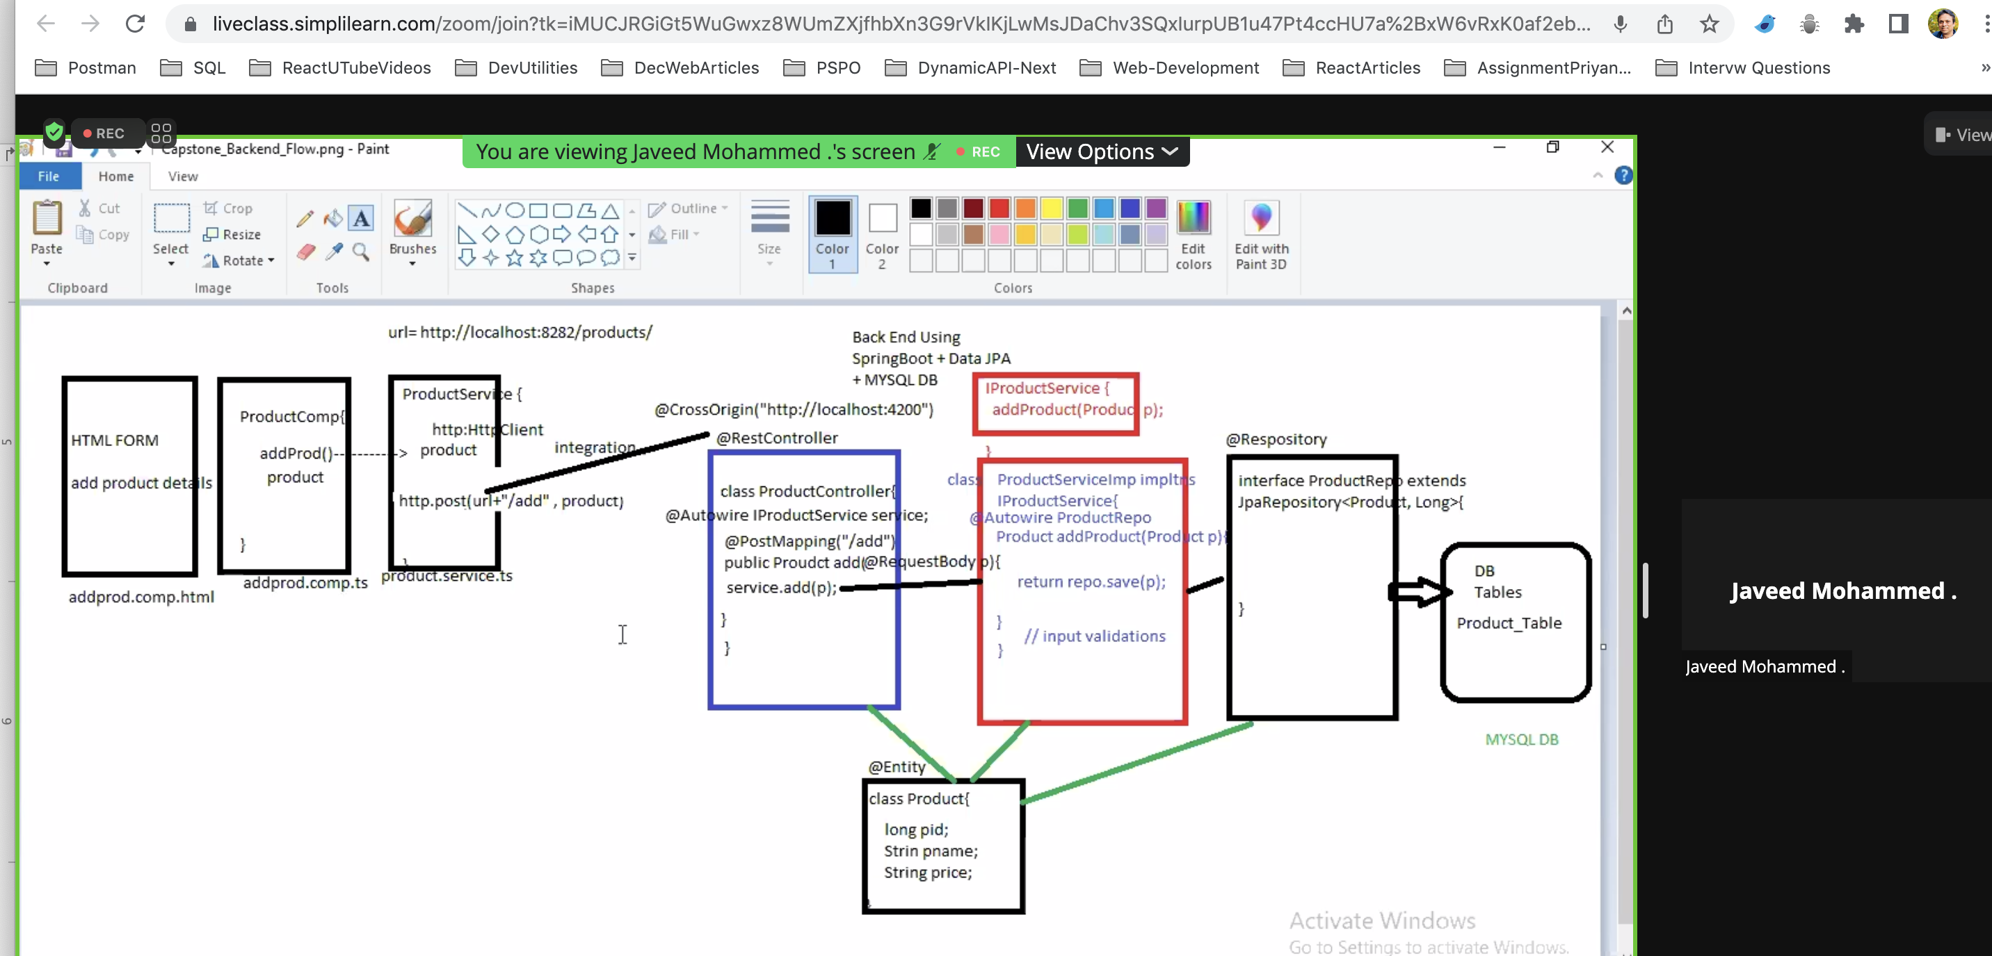

List Of Food Items:-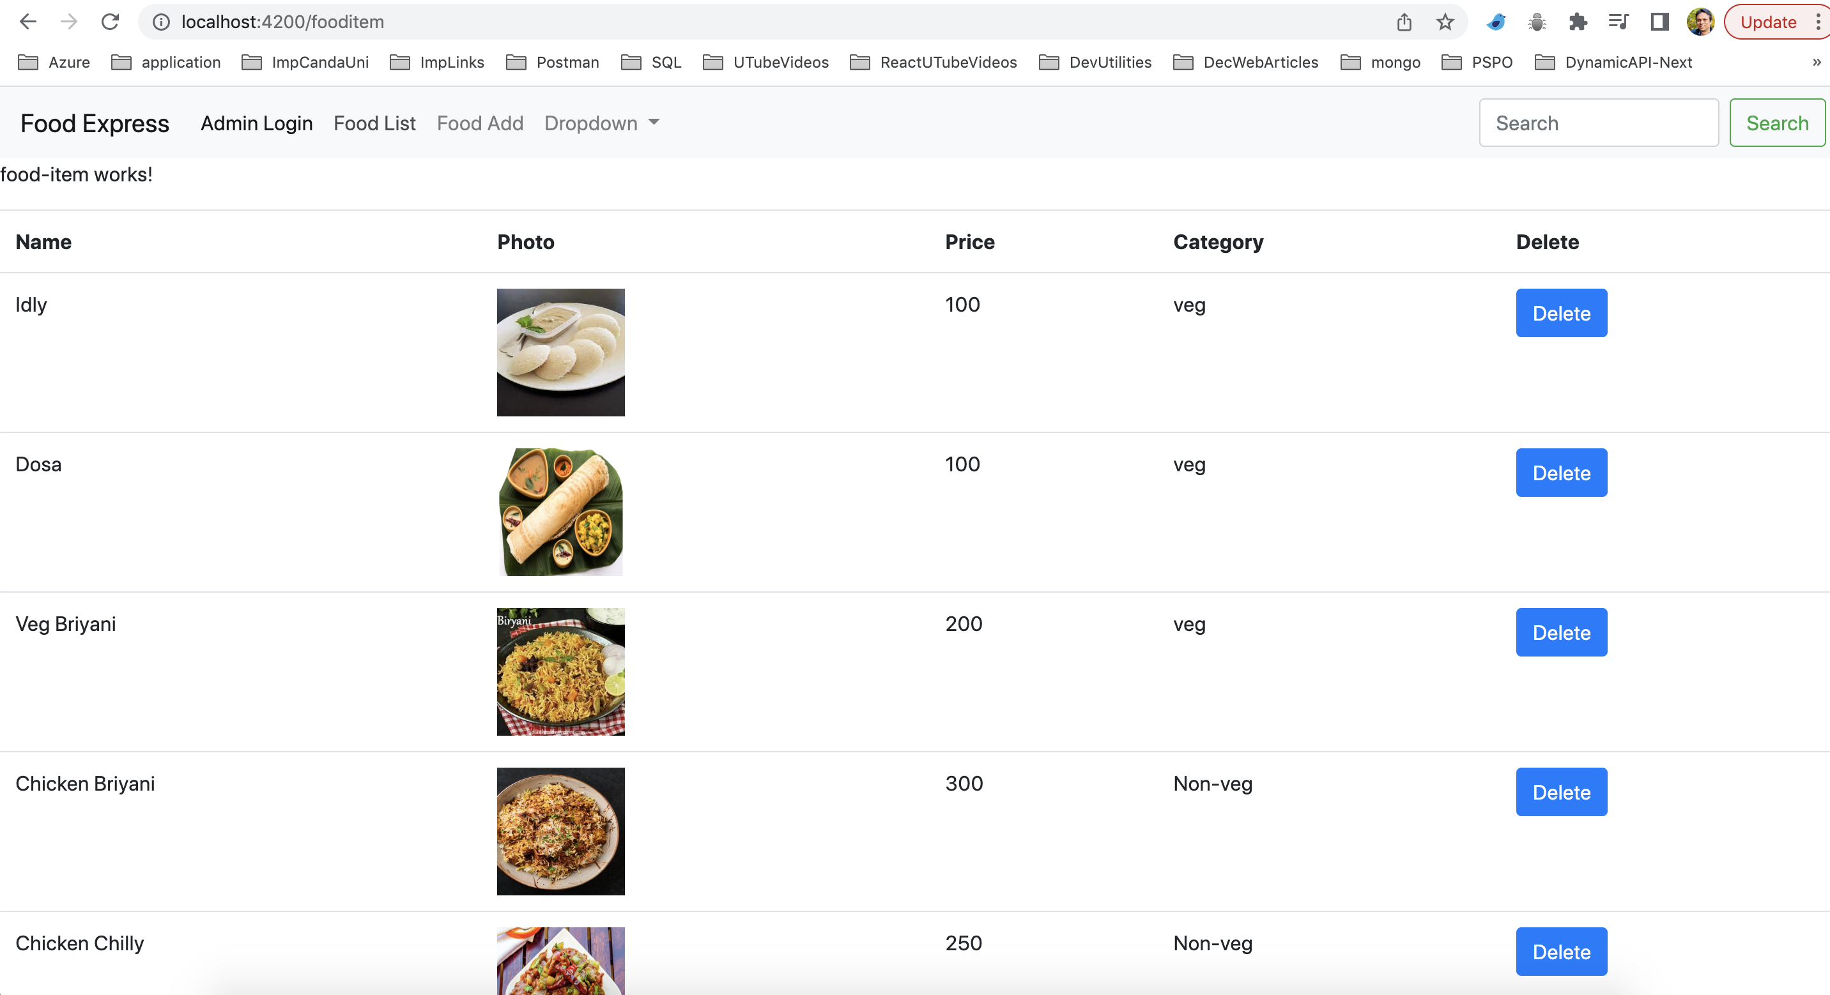

Add Food Item:-

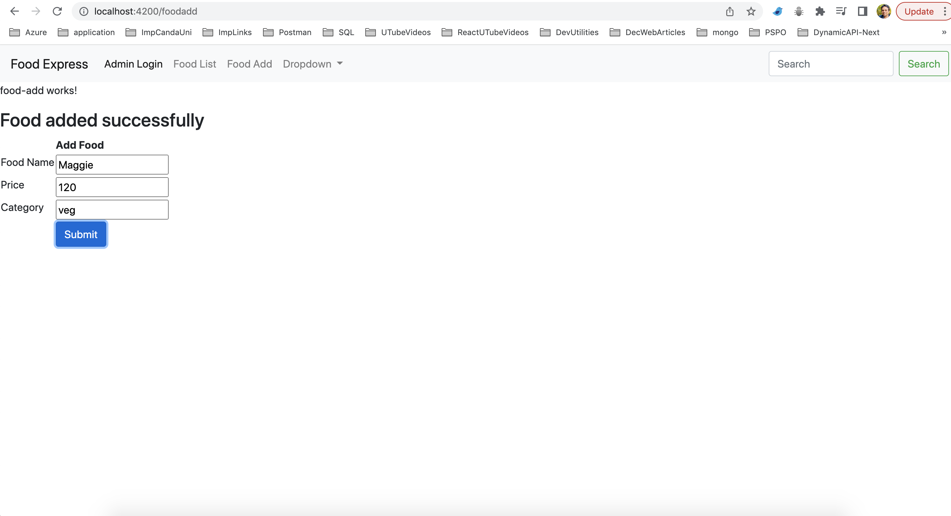

Admin Login Page:-

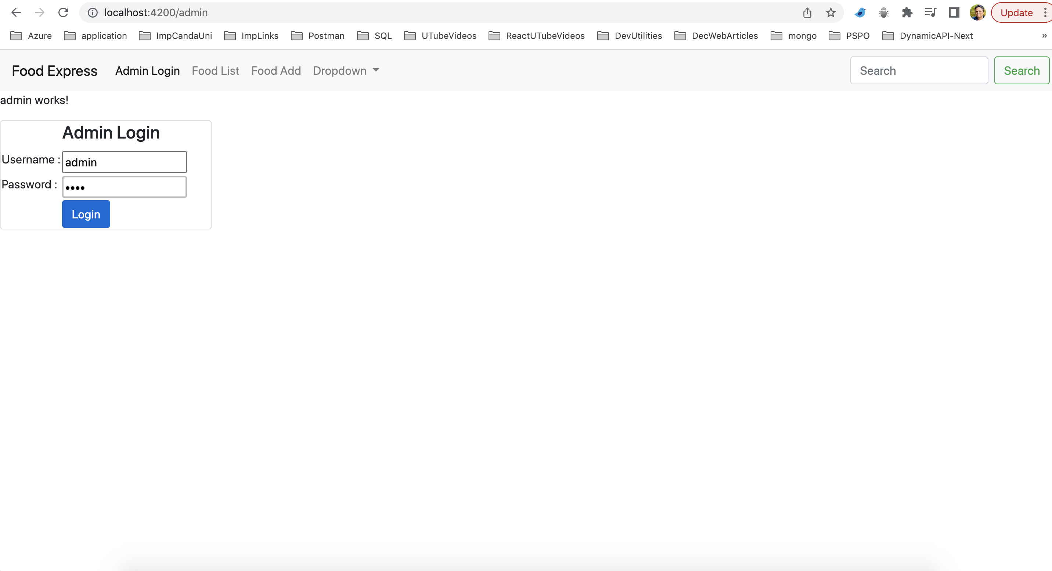

Search Page for veg category:-

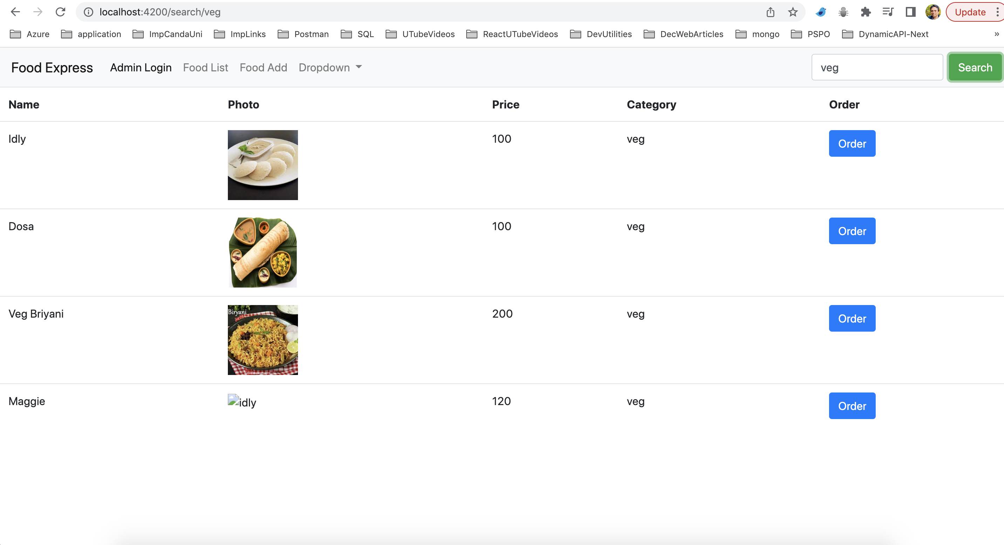

Payment Page with customer Details:-

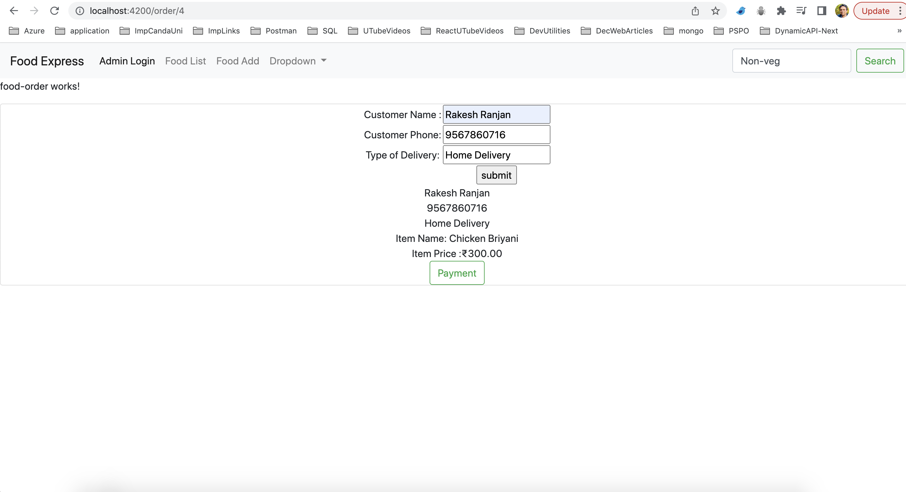

Payment Page:-

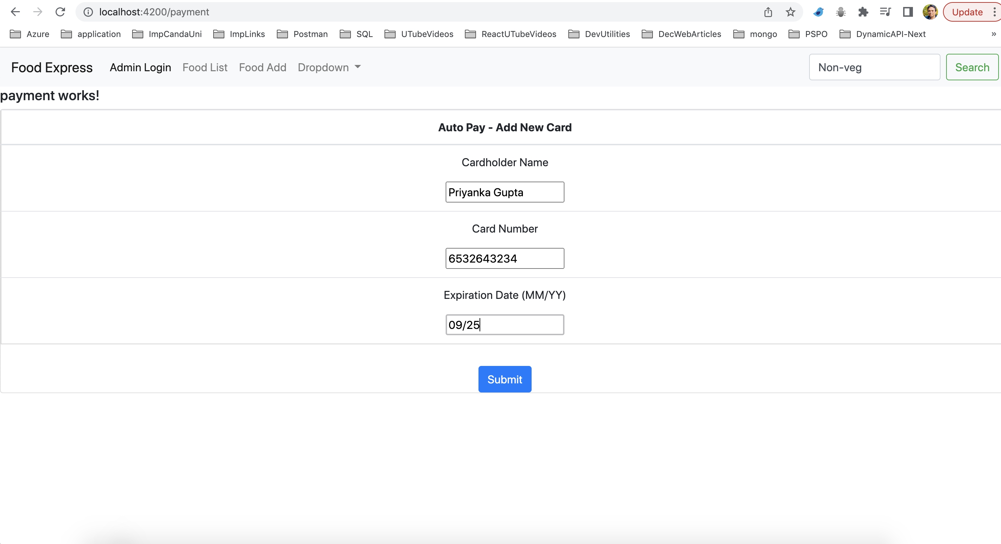

Order Confirmation Page:-

